SWECC004 — Soil analysis
Description of soil-team results
Natuurbegraafplaats Huis ter Heide, De Moer (Zeist) — seven oaks
Nālani Balcells · Avans University of Applied Sciences · June 2026

1. Purpose and scope
This document summarises the seven-tree soil dataset collected for project SWECC004 at Natuurbegraafplaats Huis ter Heide, with the same trees (FT01–FT03 Bokashi, NFT04–NFT06 Untreated, HT07 Healthy reference) sampled by the leaf team. It is intended as the soil-side companion to the integrated leaf-and-soil comparison document and to the WECC03_soil_analysis.R script. Each indicator below is reported per tree; the unit of analysis is the tree (n = 3 Bokashi, n = 3 Untreated, n = 1 Healthy reference). Differences between treatments are described descriptively, since with three replicates per treatment formal hypothesis testing is not informative.
Eight soil indicators were measured: MP-AES mineral content (Al, Mn, Cu, Zn, Fe), pH in three extractants (KCl, CaCl₂, demi-water), Hach-Lange colorimetric nitrate, phosphate and ammonium, gravimetric water content, double-ring infiltration rate, earthworm density by mustard extraction, and fungal community structure from PDA-plate counts of eleven colony morphotypes. All values used here are taken directly from the soil-team master workbook (Calibration curves and results.xlsx).

2. Soil pH
All seven trees grow on uniformly strongly acidic soils. In the reportable CaCl₂ extraction, pH ranges from 3.10 at NFT06 to 3.40 at NFT05, with a between-tree mean of 3.28 and no consistent separation by treatment (Bokashi mean 3.33, Untreated 3.24, Healthy 3.22). The KCl and demi-water extractions follow the same ordering of trees but at higher absolute values (KCl mean 3.23; demi-water mean 4.40), reflecting the conventional offset between extractants rather than any new biological information. The implication is that two applications of bokashi have not detectably modified soil pH on the timescale of this measurement, and that any further leaf-level interpretation involving pH-driven micronutrient availability must hold pH approximately constant across the study trees.
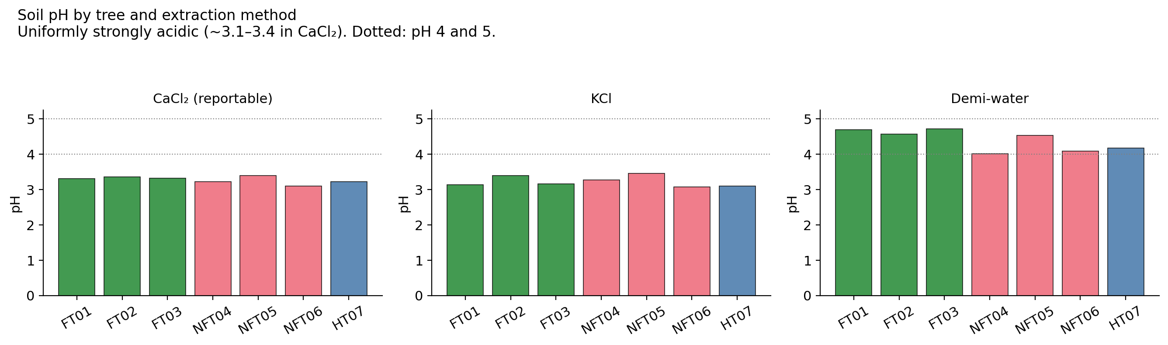
Figure 1. Soil pH per tree under three extraction methods. CaCl₂ (reportable) sits uniformly between 3.1 and 3.4 across the seven trees; KCl and demi-water reproduce the same ordering at a higher offset.

3. Hach-Lange nutrient results (NO₃, PO₄, NH₄)
Hach-Lange colorimetric analysis is the source of the cleanest treatment signal in the entire soil dataset. Phosphate concentration in the bokashi soils averages 4.96 mg kg⁻¹ (range 4.22–5.96) against an untreated mean of 0.90 mg kg⁻¹ (range 0.64–1.36); every bokashi replicate exceeds every untreated replicate, an approximately five- to six-fold separation. Ammonium follows the same direction (bokashi mean 7.25 mg kg⁻¹ vs untreated 5.21), although the within-group variance is larger. Nitrate, by contrast, is similar between the two treated groups (bokashi 9.32, untreated 8.99 mg kg⁻¹), indicating that the bokashi-driven nitrogen pool is held in the ammonium form rather than nitrified to nitrate at this site. The healthy reference at HT07 is the upper outlier on every Hach-Lange analyte (NO₃ 18.6, PO₄ 12.8, NH₄ 3.5), confirming visually that it was selected as a reference for good reason.
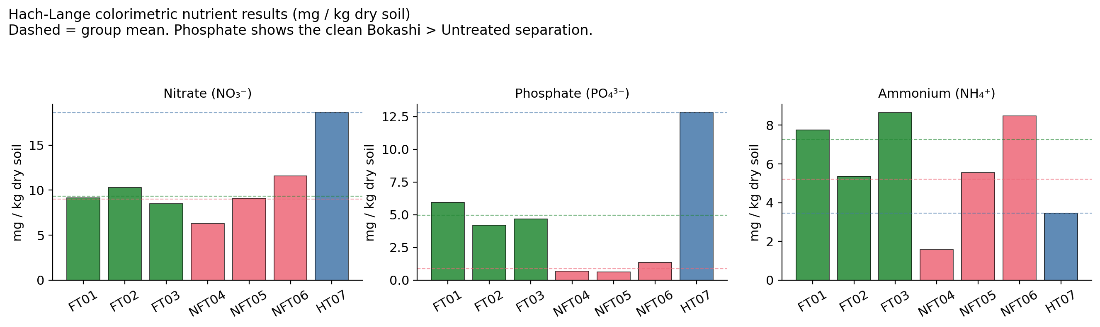
Figure 2. Hach-Lange colorimetric NO₃, PO₄ and NH₄ in mg kg⁻¹ dry soil. Dashed lines mark group means; the phosphate panel shows the clean Bokashi > Untreated separation that drives most of the integrated bokashi signal.

4. Earthworm density (mustard extraction)
Earthworm counts run counter to the bokashi direction at this single time point. The untreated trees average 700 worms m⁻² (range 600–800), the bokashi trees average 467 worms m⁻² (range 200–800), and the healthy reference at HT07 sits at 300 worms m⁻². The bokashi group's lower mean is driven primarily by FT01 (200 worms m⁻², the lowest of any tree); FT02 and NFT06 are tied for the highest density at 800 worms m⁻². Because a mustard extraction reflects worm activity at one time on one day, this single-round result depends heavily on local moisture, recent rainfall and litter availability; it is therefore not, by itself, a sensitive bokashi indicator and should be repeated across the season before any management conclusion is drawn from it.
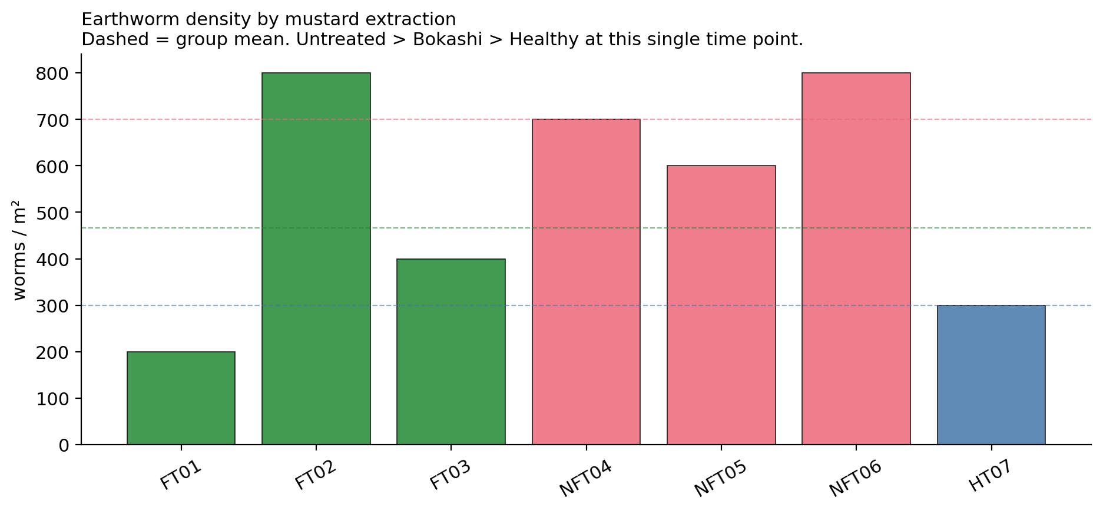
Figure 3. Earthworm density per tree. Dashed lines mark group means. FT01 is the low outlier of the bokashi group; FT02 and NFT06 are tied at the top.

5. Fungal community structure
Fungal community structure was characterised from PDA-plate counts of eleven colony morphotypes per tree, replicated three times. Raw abundance differs strongly between trees (FT01 589 colonies vs NFT04 100 colonies on the same plating effort), but this difference is driven almost entirely by one morphotype on FT01's plates rather than by community-wide colonisation. Once the counts are summarised as ecological indices, the picture flattens: Shannon H′ ranges from 0.72 (NFT04) to 1.26 (NFT05) with both treated groups falling in the middle (Bokashi mean H′ 0.98, Untreated 1.00), and evenness J is similarly indistinguishable between treatments. Richness (number of morphotypes per tree) is highest at FT03 (7.3) and lowest at FT01 (5.0). The healthy reference HT07 has neither the highest abundance nor the highest diversity of any tree — its community is simply average-to-slightly-above on every index.
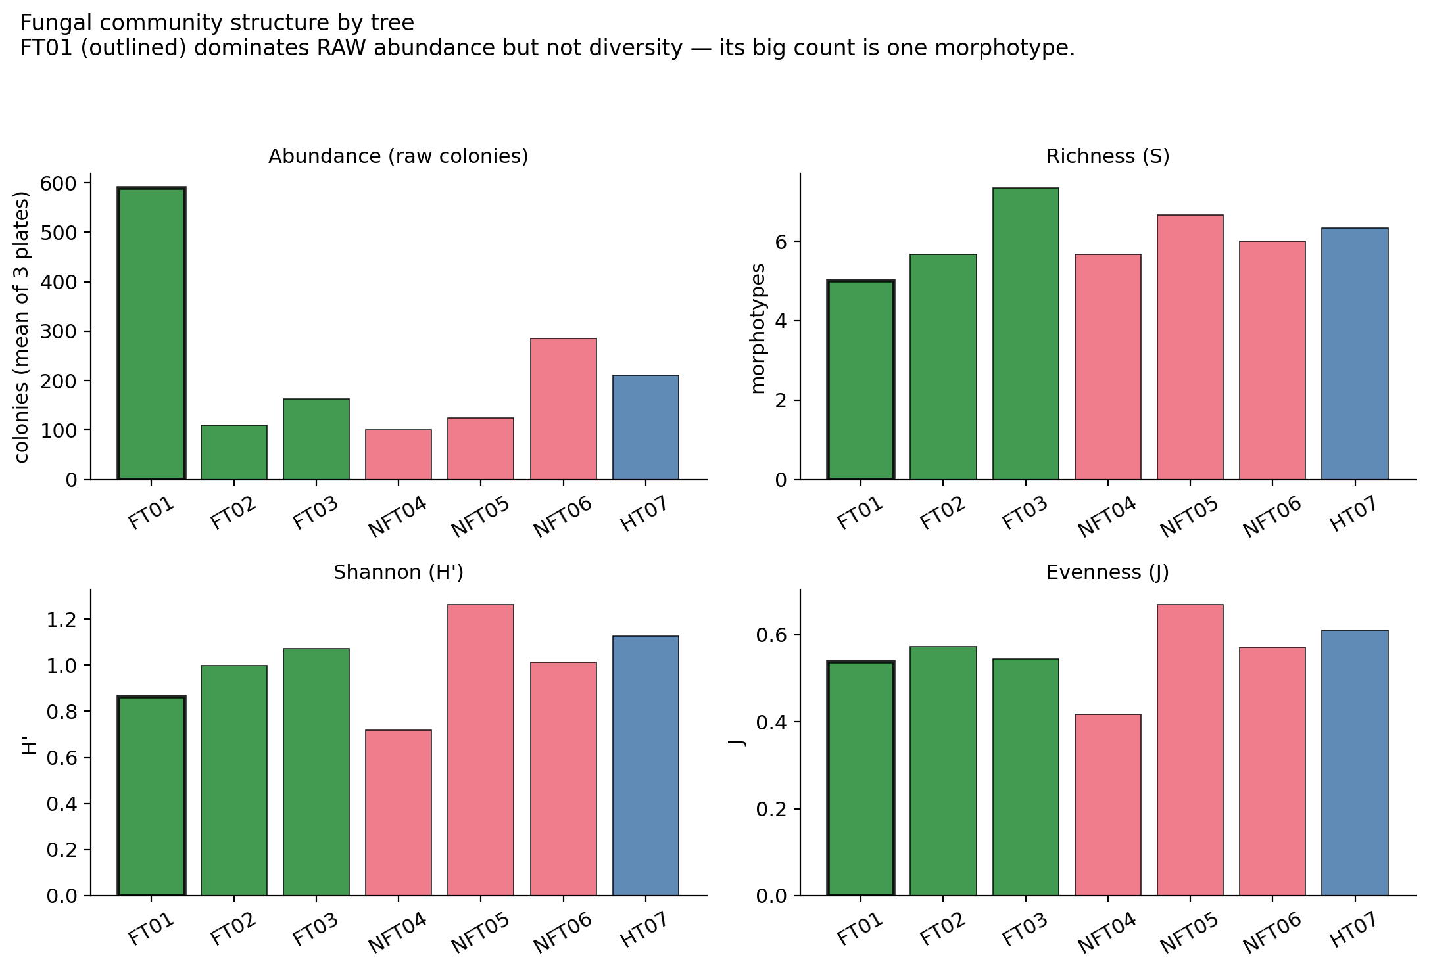
Figure 4. Fungal community structure per tree. FT01 (outlined) dominates raw abundance but not richness, Shannon H' or evenness — its high colony count is one morphotype.

6. Soil water content (gravimetric)
Gravimetric water content (mL of water per ≈10 g wet soil, three replicates per tree) is the indicator with the widest absolute spread in the dataset, ranging from 2.21 mL at NFT04 to 7.40 mL at NFT05. Within-tree replicates are very consistent (typical SD < 0.2 mL), so this spread reflects real between-tree variation in soil moisture status on the day of sampling rather than measurement noise. Bokashi trees are clustered between 4.3 and 5.6 mL with low within-tree variability; the untreated group is bimodal, with NFT04 very dry and NFT05–NFT06 wet. No water-content measurement was made at HT07. The pattern is therefore that bokashi soils are tightly grouped at intermediate moisture, while untreated soils are highly variable.
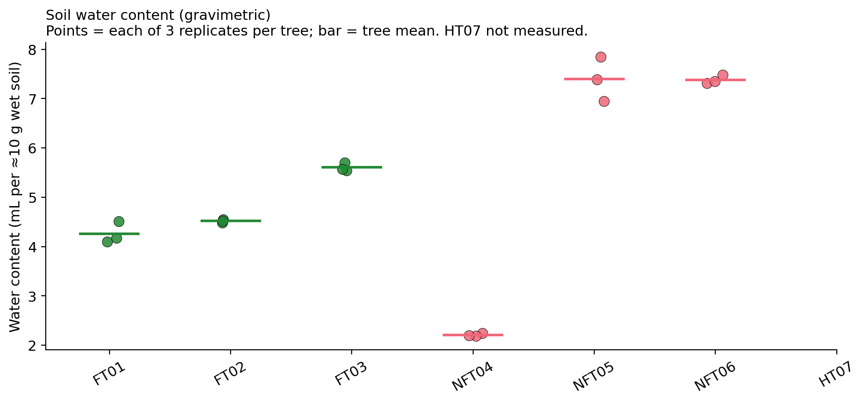
Figure 5. Gravimetric soil water content per tree. Each point is one replicate; horizontal bar is the tree mean. HT07 was not measured.

7. Infiltration / permeability
Mean infiltration flow rate, measured with a double-ring infiltrometer over 5–11 intervals per tree, separates FT01 from every other tree in the dataset. FT01 infiltrates at 4.3 mm min⁻¹, approximately an order of magnitude slower than its bokashi group-mates FT02 (39.1) and FT03 (37.9), and slower than every untreated tree (28.1, 38.9, 18.7 for NFT04, NFT05 and NFT06 respectively). The mean infiltration of the bokashi group is therefore not representative — it is driven by two of three trees, with the third behaving as a separate physical regime. Group means are otherwise near-identical (Bokashi 27.1, Untreated 28.6 mm min⁻¹), so there is no detectable bokashi effect on infiltration once FT01's anomaly is set aside. HT07 was not measured.
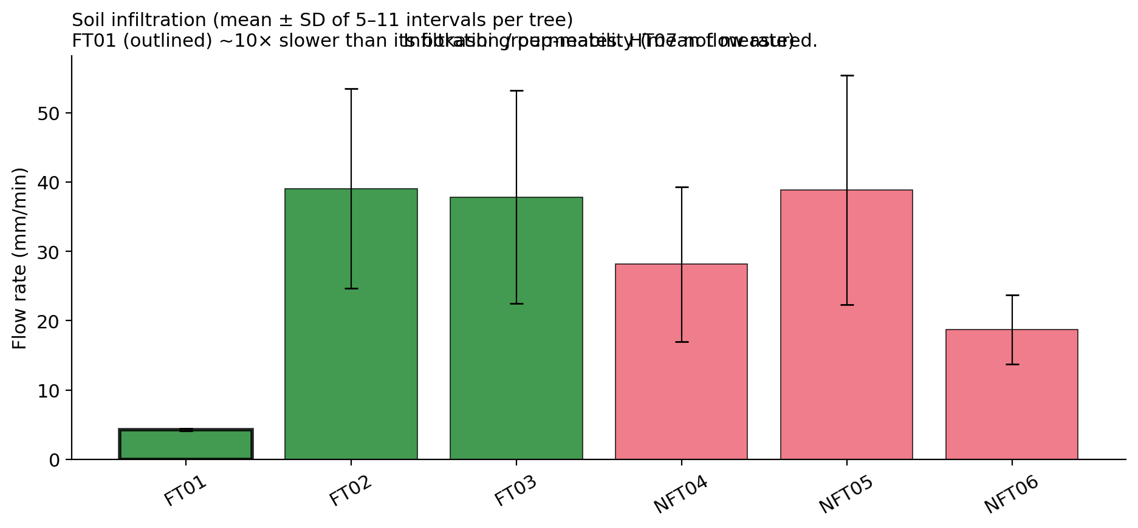
Figure 6. Mean infiltration flow rate per tree (error bars = SD across 5–11 intervals). FT01 (outlined) infiltrates ~10× slower than its bokashi group-mates.

8. Soil mineral concentrations (MP-AES)
MP-AES analysis on the five reliable emission lines (Al 396, Mn 403, Cu 324, Zn 481 and Fe 372 nm) returned soil mineral concentrations in mg L⁻¹ in solution after acid digestion. Aluminium dominates the soil mineral pool at every tree, ranging from 9.8 mg L⁻¹ at FT03 to 24.3 mg L⁻¹ at NFT06 (untreated mean 20.3 vs bokashi mean 13.5). This is the only soil-mineral signal that differentiates the treatments at any scale, and it does so in the direction expected if bokashi tempers acid-mediated Al mobilisation. Iron, manganese, copper and zinc are essentially indistinguishable between the treated groups: Fe ~1.9–2.2 mg L⁻¹, Mn ~1.3, Cu ~0.6–0.7, Zn ~1.0 mg L⁻¹ across all trees. The healthy reference HT07 sits within the bokashi range for every element. Note that these soil-side concentrations are reported in mg L⁻¹ in solution and are therefore not directly comparable in absolute terms with the leaf-side concentrations in ppm in the leaf digest; the inter-substrate comparison in the integrated document handles this by relating direction of change rather than absolute magnitude.
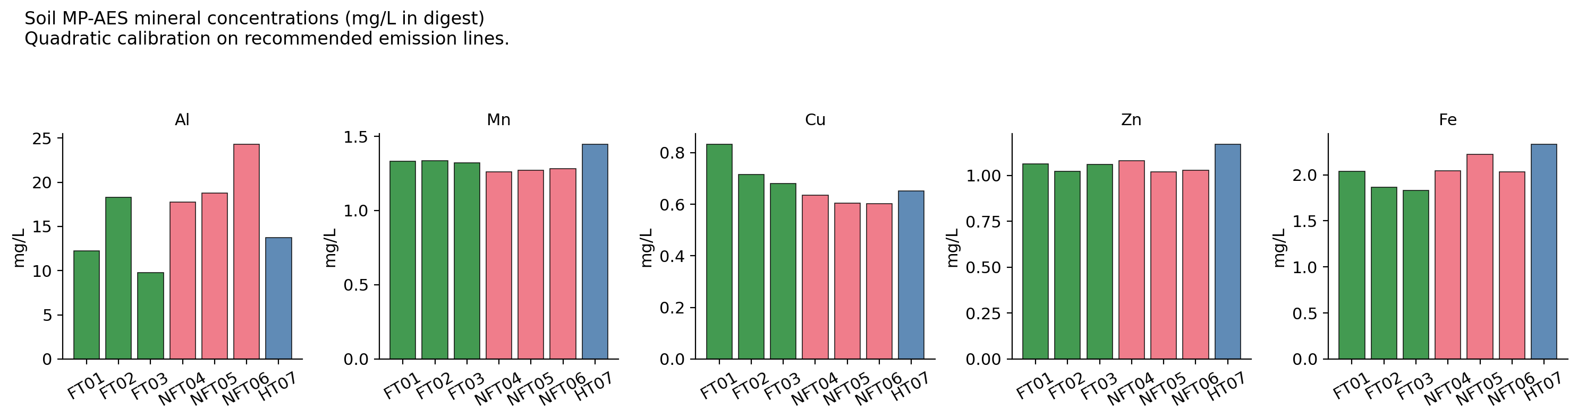
Figure 7. Soil mineral concentrations per tree from MP-AES, quadratic calibration on recommended emission lines. Aluminium is the only element with a clear treatment-level difference (Untreated > Bokashi).

9. Integrated soil picture and within-tree anomalies
Read across all eight indicators, the soil dataset supports three statements. First, bokashi has a clear chemical signature in the Hach-Lange phosphate (and to a lesser extent ammonium) concentrations and a smaller signature in soil aluminium; it does not measurably change pH, nitrate, fungal community structure, infiltration rate or earthworm density at the scale of this single-round dataset. Second, the most influential within-treatment difference is at FT01, which combines the slowest infiltration of any tree, the lowest earthworm density, low water content for the bokashi group, and a fungal community dominated by a single morphotype. The leaf-level chemistry of FT01 is not particularly anomalous, which suggests that the FT01 soil profile reflects a local physical-structural issue rather than a treatment failure. Third, the healthy reference HT07 is the upper outlier on the Hach-Lange chemistry (especially phosphate and nitrate) without being extreme on any biological or physical indicator — its soil chemistry is simply richer, consistent with its status as a target benchmark.

10. Limitations of the soil dataset
Three limitations apply to the soil-only conclusions. First, the design is a single-round snapshot with three replicates per treatment and one healthy reference, which is sufficient to describe direction of effect but not magnitude. Second, the MP-AES results are reported in mg L⁻¹ in the analysed solution rather than mg kg⁻¹ dry soil, because the digestion mass and dilution were placeholders in the calibration; converting to soil-mass-normalised units before reporting is recommended once the digestion records are available. Third, the earthworm and infiltration measurements were each performed once per tree on a single day and reflect local conditions on that day; both indicators would benefit from a second sampling round in different weather to establish baseline variability before being used as routine monitoring metrics.

Files included in this folder
WECC03_soil_analysis.R — MP-AES soil-mineral analysis script (quadratic and inverse-multivariate calibration, soil PCA).
soil_pH.csv, soil_hach_lange.csv, soil_water_content.csv, soil_infiltration.csv, soil_earthworms.csv, soil_fungi_raw_counts.csv, fungal_diversity_per_tree.csv, soil_concentrations.csv — raw per-tree soil data from the soil-team master workbook.
soil_fig1_pH.png … soil_fig7_minerals.png — the standalone soil-team figures reproduced in this document, generated from the raw CSVs.
SWECC004_soil_description.docx — this document.

